**Note: This App might not looks like below provided screenshots when you check on play store cause of update on app (Pdf created on 17 Aug 2022)**

**Sim Recharge Tax Calculator App (Android):**

PTA (Pakistan Telecom Authority) Sims Recharge Tax Calculator that helps peoples of Pakistan to calculate the tax on the recharge amount. The tax on recharged amount might not same for all the sims ( Ufone , Mobilink Jazz , Telenor , Zong ) so that different features in the app will provide to calculate the recharge tax.

🎉 Elegant User Interface.

🎉 Responsiveness In app, works on both dimensions portrait and landscape.

🎉 Different operator ( zong , ufone , jazz , warid , telenor ) based different

Screen for calculating recharge tax

🎉 Provinces Based Tax Calculation

🎉 User friendly experience

🎉 Google Admob Ads Implementation (Banner Ad, Interstitial Ad)

**Portrait Light Mode:**

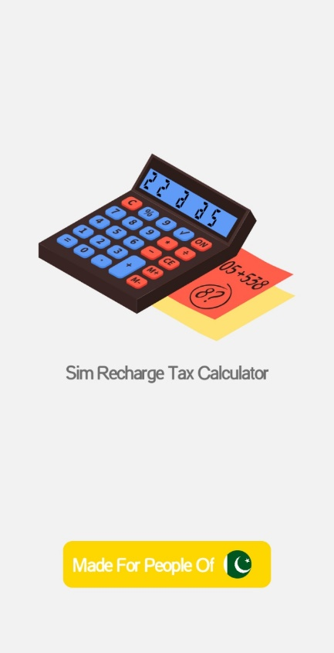 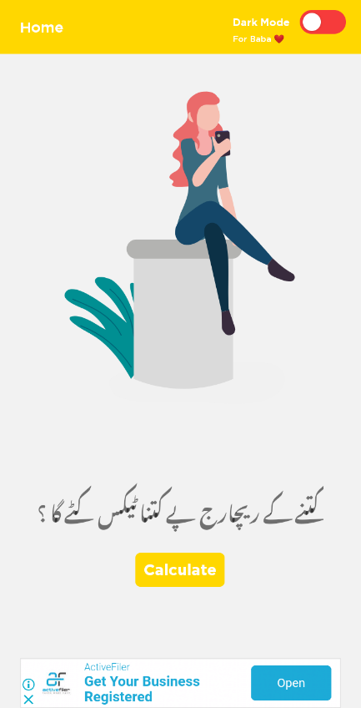 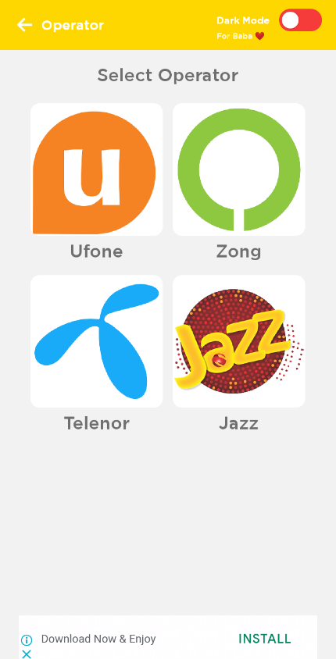 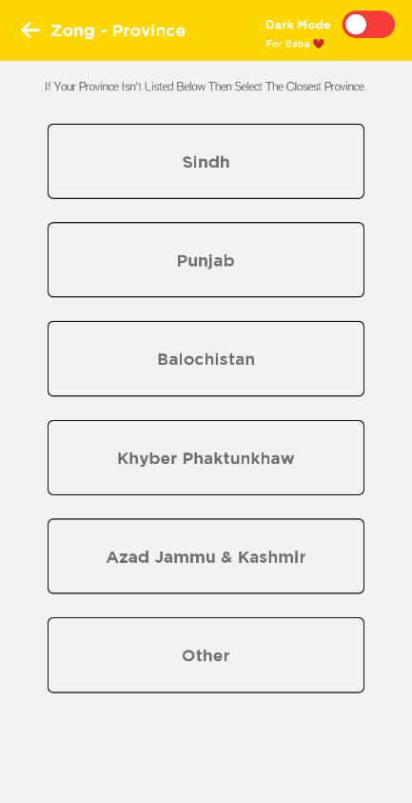 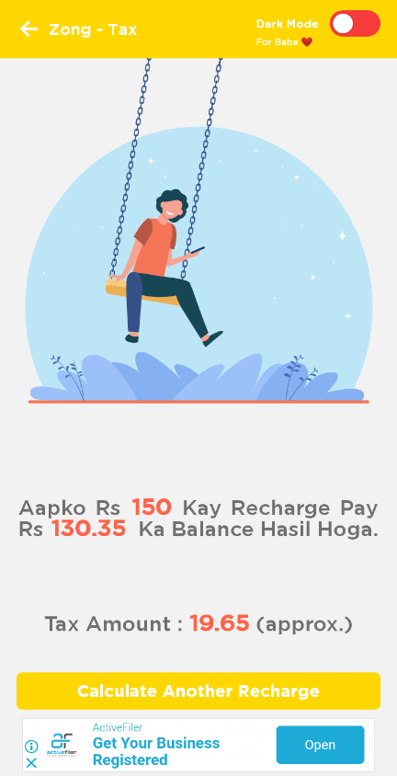 

**Portrait Dark Mode:**

 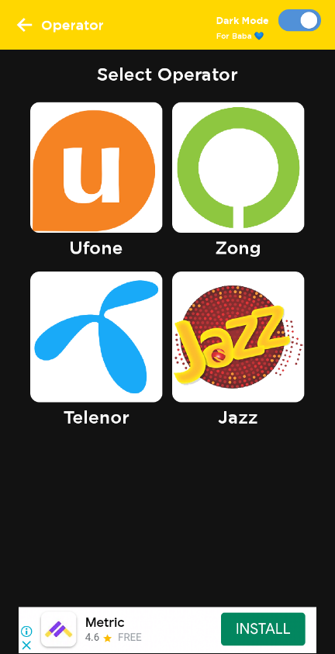  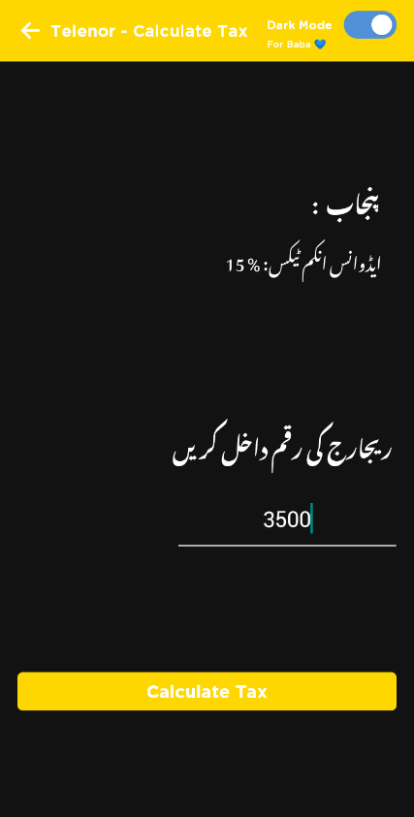 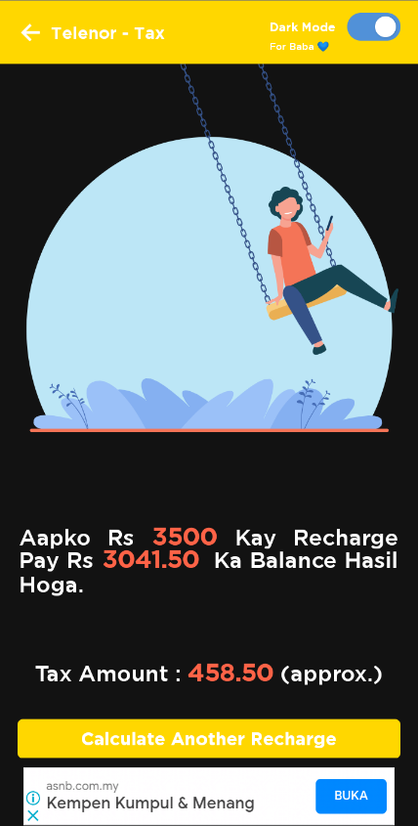

**Landscape Light Mode:**

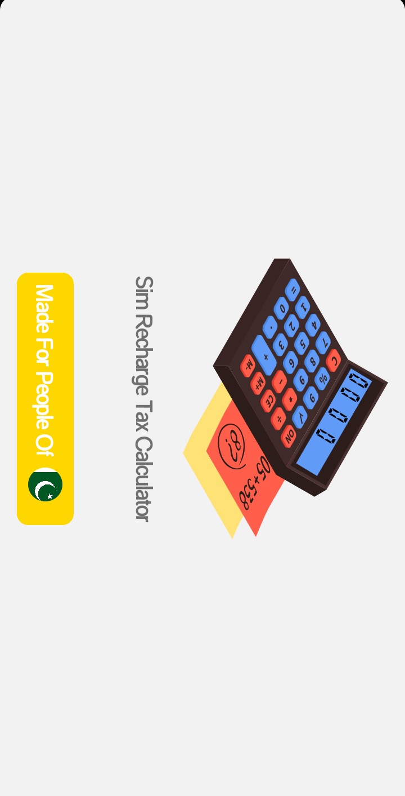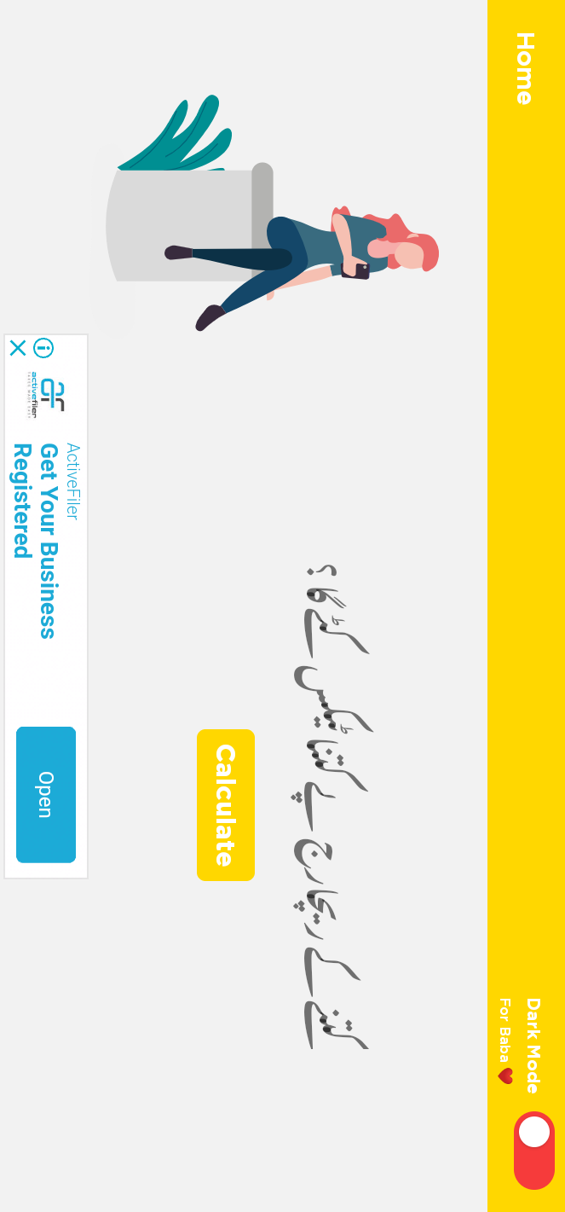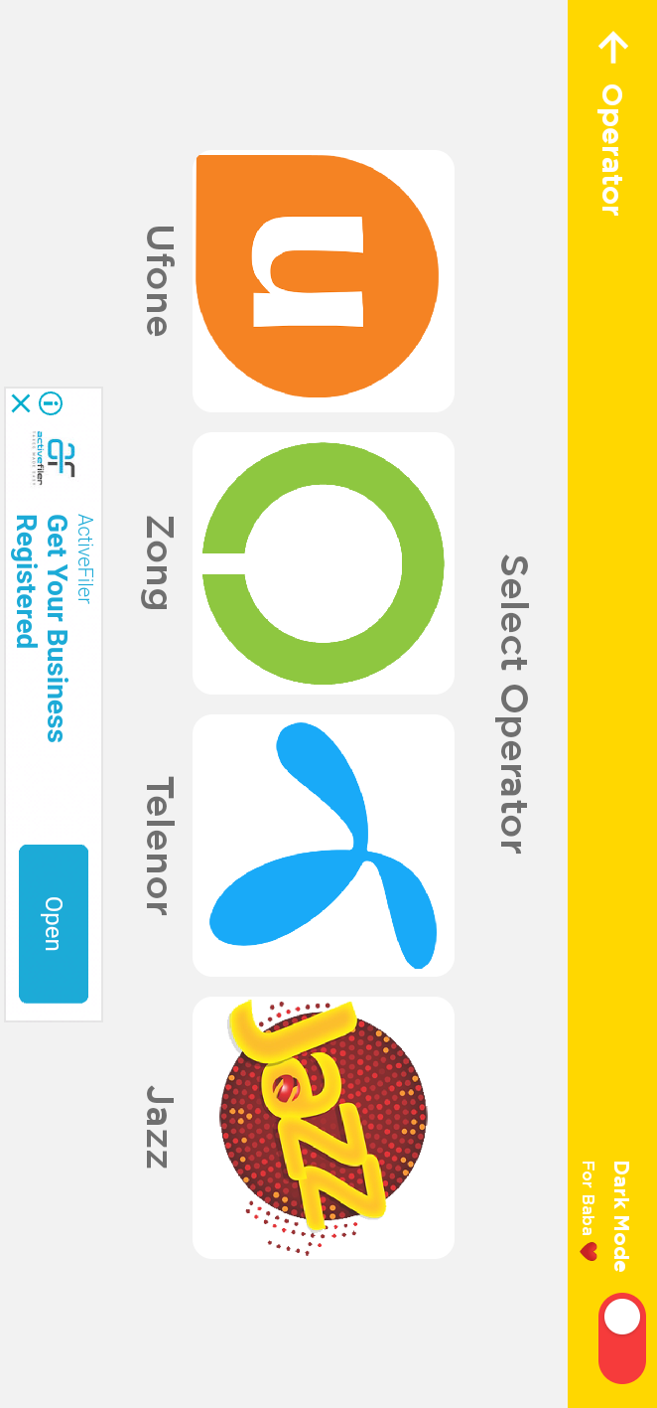

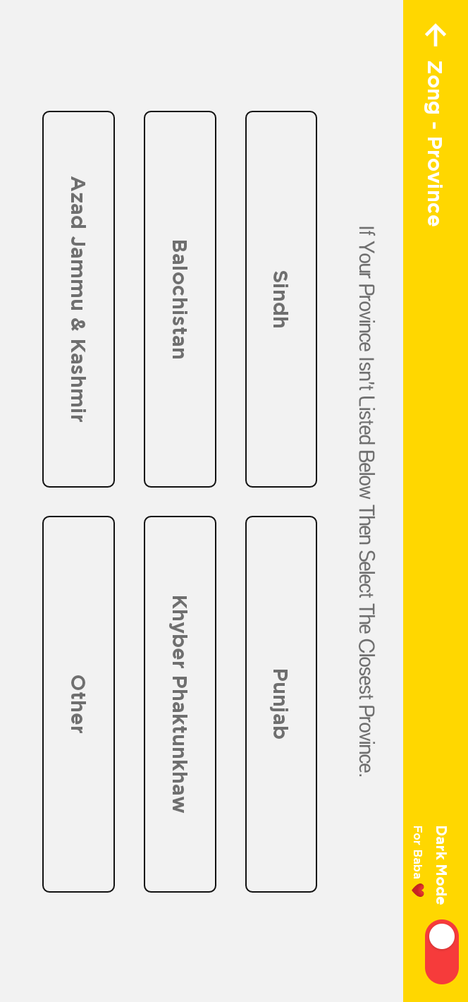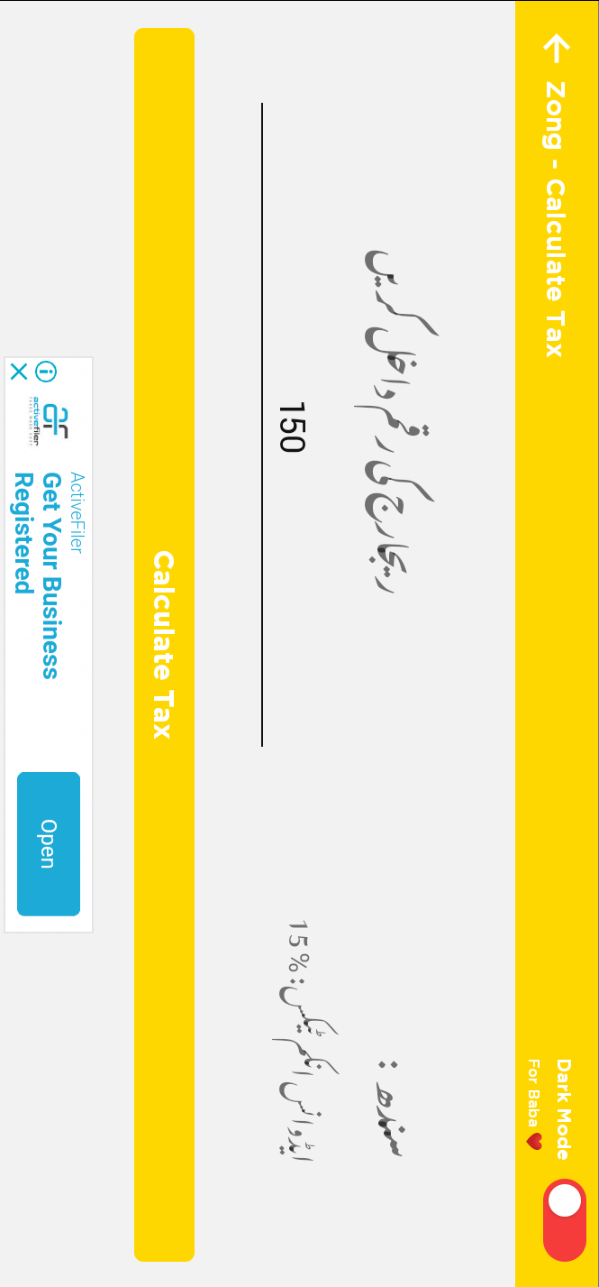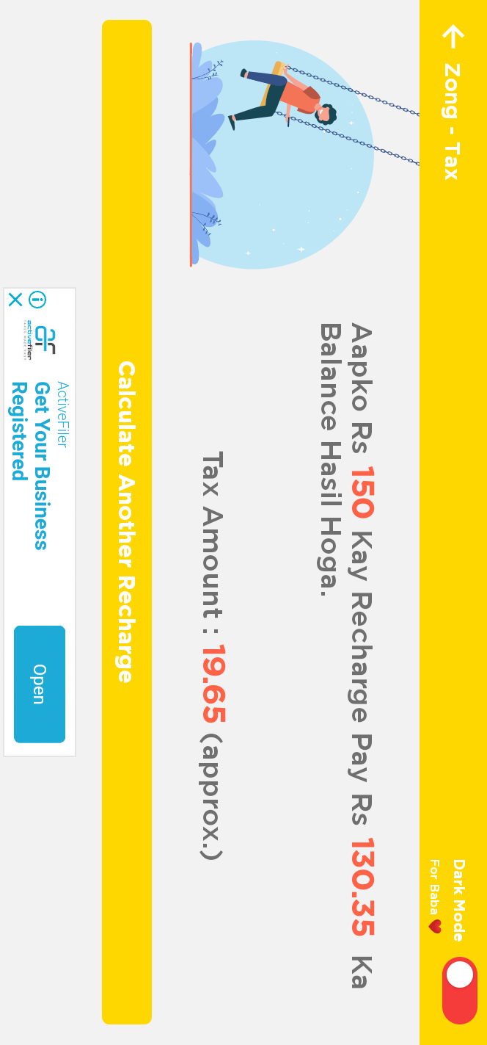

**Landscape Dark Mode:**

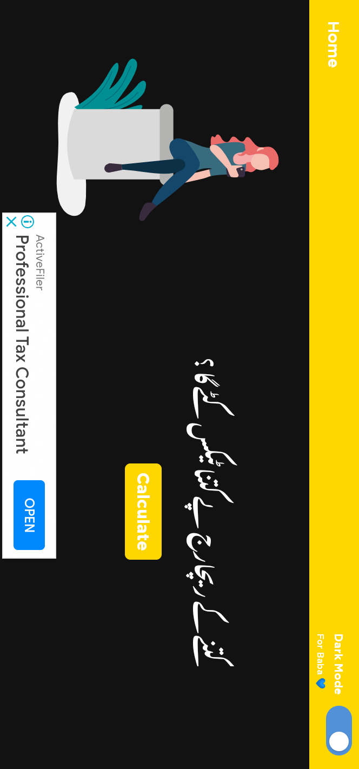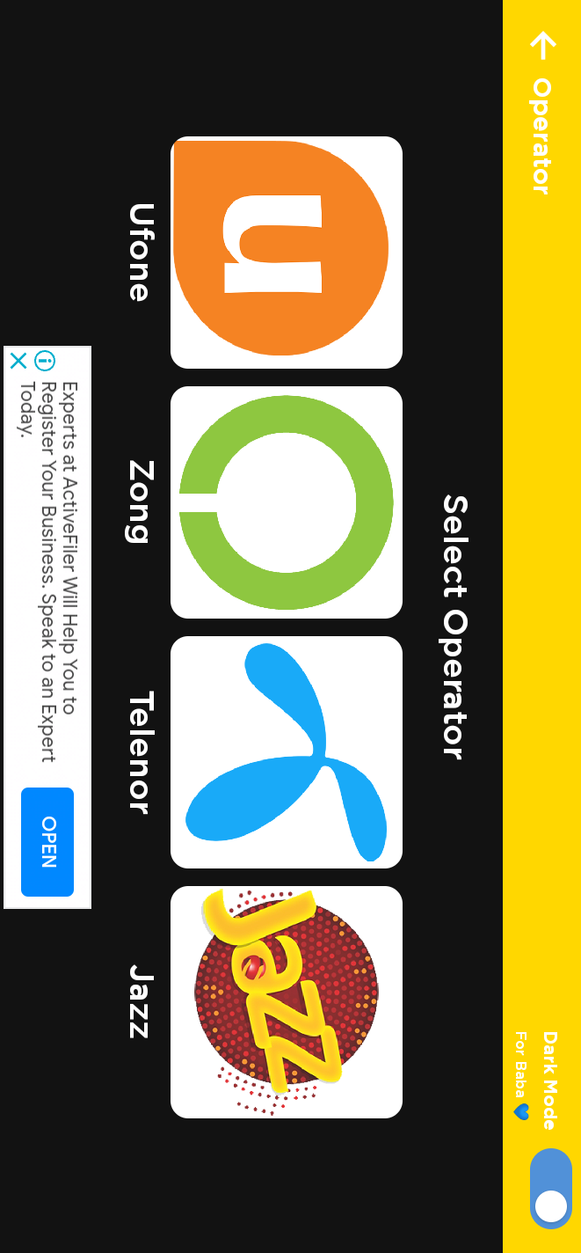

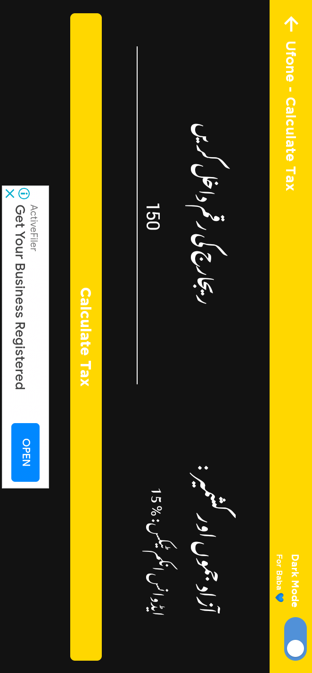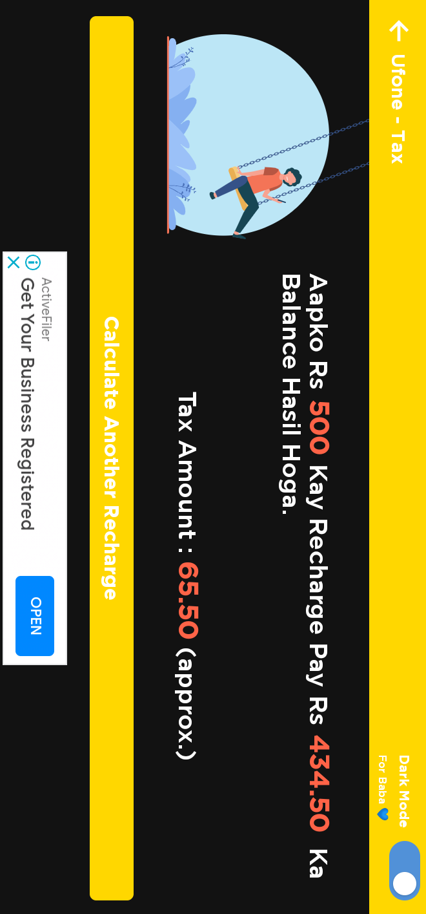

**PlayStore Link:** [**https://play.google.com/store/apps/details?id=com.ptasimsrechargetaxes**](https://play.google.com/store/apps/details?id=com.ptasimsrechargetaxes)

**ApkLink:**

[**https://www.mediafire.com/file/m2ccadu75bf1vxp/Sim_Recharge_Tax_Calculator.apk/file**](https://www.mediafire.com/file/m2ccadu75bf1vxp/Sim_Recharge_Tax_Calculator.apk/file)(might not updated link, means not same as play store app)

**App Icon:**

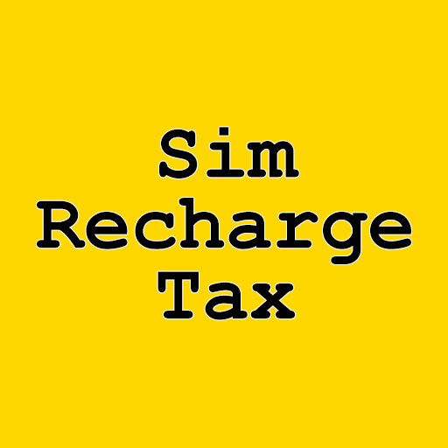

**App Feature Graphic:**

